**Exercise 2**

1. Create a folder to store all your working files

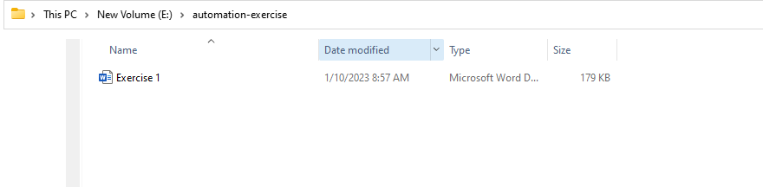

1. Open notepad and type a simple java program to print ‘Hello world’ on the screen

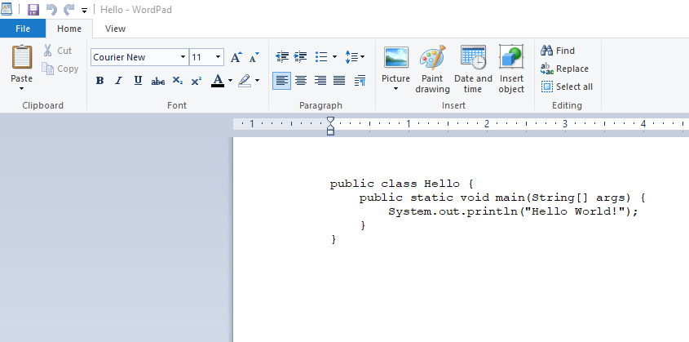

1. Save the program as Hello.java under your working folder

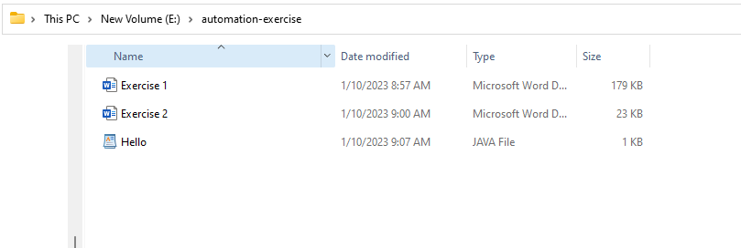

1. Open command prompt and try to compile your program using javac

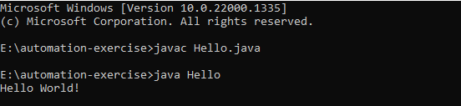

5) Execute your program in the command prompt using the command java

